Abstract
This report details the analysis of Photoplethysmogram (PPG) signals for heart rate monitoring and abnormality detection. It includes preprocessing, peak detection, heart rate calculation, and identification of abnormalities such as bradycardia, tachycardia, and irregular heartbeats. The report includes placeholders for visualizations.

Scope
- Data Acquisition: Load PPG signal data from a CSV file.
- Preprocessing: Apply bandpass filtering to remove noise.
- Peak Detection: Identify R-peaks using the find_peaks function.
- Heart Rate Calculation: Compute RR intervals and heart rate.
- Abnormality Detection: Detect bradycardia, tachycardia, and irregular heartbeats.
- Visualization: Plot raw and filtered signals, R-peaks, heart rate trends, and abnormalities.
- Report Generation: Provide heart rate statistics and detected abnormalities.

Code Implementation Import Required Libraries
import numpy as np from scipy.signal import butter, filtfilt, find_peaks import matplotlib.pyplot as plt import pandas as pd

Define PPGAnalyzer Class
class PPGAnalyzer: def __init__(self, sampling_rate=100):
self.fs = sampling_rate self.ppg_data = None self.filtered_data = None self.r_peaks = None self.rr_intervals = None self.heart_rates = None

Load Data
def load_data(self, file_path): try:
self.ppg_data = pd.read_csv(file_path).iloc[:, 0].values return True except Exception as e:
print(f'Error loading data: {e}') return False

Bandpass Filter
def bandpass_filter(self, lowcut=0.7, highcut=7.5):
nyquist = 0.5 * self.fs low = lowcut / nyquist
high = highcut / nyquist b, a = butter(2, [low, high], btype='band') self.filtered_data = filtfilt(b, a, self.ppg_data)

Detect R-Peaks
def detect_r_peaks(self, height=None, distance=None): if height is None:
height = 0.5 * np.max(self.filtered_data) if distance is None:
distance = int(0.4 * self.fs) self.r_peaks, _ = find_peaks(self.filtered_data, height=height, distance=distance)

Analyze Heart Rate
def analyze_heart_rate(self):
self.rr_intervals = np.diff(self.r_peaks) / self.fs self.heart_rates = 60 / self.rr_intervals

Detect Abnormalities
def detect_abnormalities(self):
abnormalities = {'bradycardia': [], 'tachycardia': [], 'irregular': []} bradycardia_idx = np.where(self.heart_rates < 60)[0] abnormalities['bradycardia'] = self.r_peaks[bradycardia_idx] tachycardia_idx = np.where(self.heart_rates > 100)[0] abnormalities['tachycardia'] = self.r_peaks[tachycardia_idx]

Main Function
def analyze_ppg_file(file_path, sampling_rate=100):
analyzer = PPGAnalyzer(sampling_rate) if analyzer.load_data(file_path): analyzer.bandpass_filter() analyzer.detect_r_peaks() analyzer.analyze_heart_rate() abnormalities = analyzer.detect_abnormalities() print('Analysis Complete', abnormalities) return abnormalities

Results
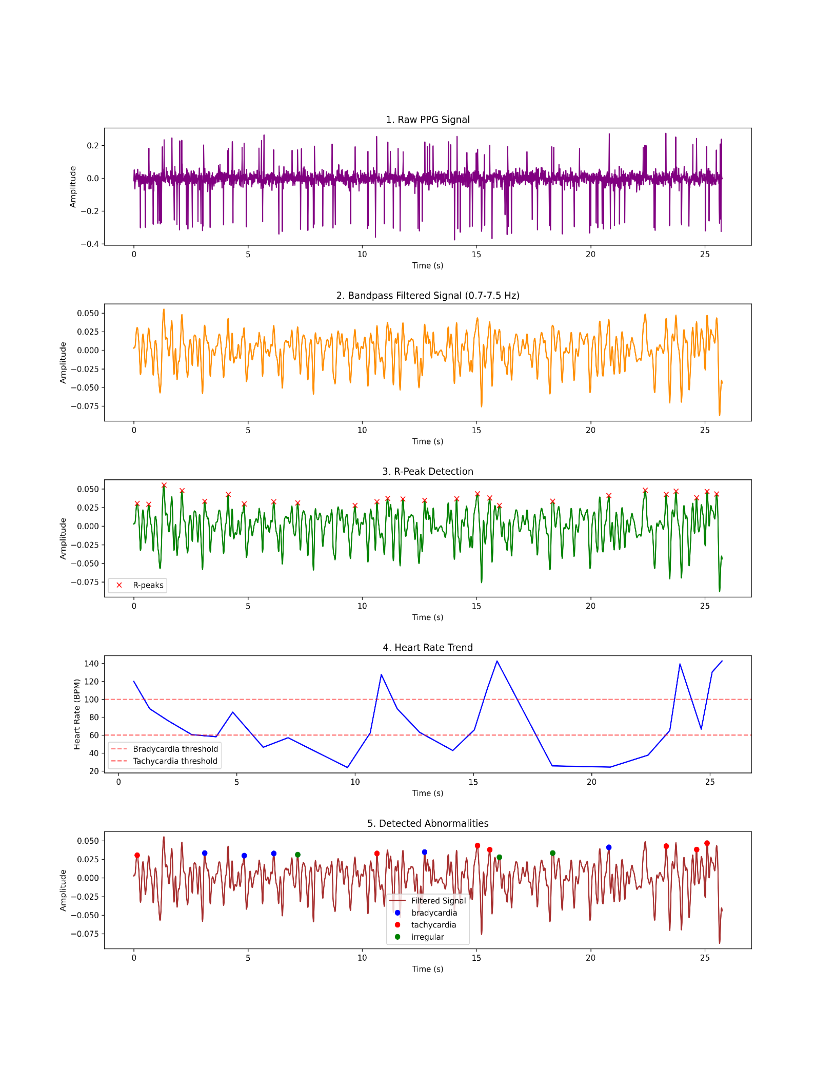

Conclusion
The PPG signal analysis system successfully extracts heart rate, detects abnormalities, and provides insights into heart health. The placeholders provided in this document should be replaced with actual plots for a complete analysis. Future improvements could include real-time processing and enhanced filtering techniques.

